**<Give Here Your Own Project Title>**

**Design Document**

**Version 1.0**



**Group Id: F230226693** (BC170403299)

**Supervisor Name : Ayyaz Altaf Mirza**  

**Revision History**

|  |  |  |  |
| --- | --- | --- | --- |
| **Date (dd/mm/yyyy)** | **Version** | **Description** | **Author** |
| 18/01/2024 | 1.0 | Introduction of the project | Write student(s) id |
|  |  | design document is use to  give a application  development team overall  guidance to the architecture  of the application project.  Design document contains  ERD, Sequence Diagram,  Architecture Design Diagram,  Class Diagram, Interface  Design and Test Cases. | BC170403299 |

**Table of Contents**

1. [Introduction of Design Document](https://products.aspose.app/words/editor/edit?id=a7b2bf30-bfc9-4f57-b89d-58846262478b%2FFall%202023_CS619_8902_2%20(1).docx#One)         Page 1
2. [Entity Relationship Diagram (ERD)](https://products.aspose.app/words/editor/edit?id=a7b2bf30-bfc9-4f57-b89d-58846262478b%2FFall%202023_CS619_8902_2%20(1).docx#ERD) Page 2
3. [Sequence Diagrams](https://products.aspose.app/words/editor/edit?id=a7b2bf30-bfc9-4f57-b89d-58846262478b%2FFall%202023_CS619_8902_2%20(1).docx#Six)   Page 3
4. [Architecture Design Diagram](https://products.aspose.app/words/editor/edit?id=a7b2bf30-bfc9-4f57-b89d-58846262478b%2FFall%202023_CS619_8902_2%20(1).docx#Seven)   Page 4
5. [Class Diagram](https://products.aspose.app/words/editor/edit?id=a7b2bf30-bfc9-4f57-b89d-58846262478b%2FFall%202023_CS619_8902_2%20(1).docx#class)     Page 5
6. [Database Design](https://products.aspose.app/words/editor/edit?id=a7b2bf30-bfc9-4f57-b89d-58846262478b%2FFall%202023_CS619_8902_2%20(1).docx#databasedesign) Page 6
7. [Interface Design](https://products.aspose.app/words/editor/edit?id=a7b2bf30-bfc9-4f57-b89d-58846262478b%2FFall%202023_CS619_8902_2%20(1).docx#interfacedesign) Page 7
8. [Test Cases](https://products.aspose.app/words/editor/edit?id=a7b2bf30-bfc9-4f57-b89d-58846262478b%2FFall%202023_CS619_8902_2%20(1).docx#testcases) Page 8
9. Introduction of Design Document

**1. Introduction of Design Document**

This phase contains following data.

* 1. Entity Relationship Diagram
  2. Sequence Diagram
  3. Architecture design Diagram
  4. Class Diagram
  5. Database Design
  6. Interface Design

**A. ERD**

A. ERD

Entity Relationship Diagram (ERD) visually shows the relationship that the entities will have in a given scenario. Entity is an object that is exists independently and can identified uniquely through a primary key.

In this system, Admin, User, Cars, Routes, Travelled History etc. are entities.

**B. Sequence Diagrams**

This represents the flow of messages of interaction between the user and the objects and classes. It can also be considered as a logical representation of system development.

**In this system, we need followings**

-Login -Logout

-Manage Cars -Remove Travelled History

-Track car -Turn tracking On/Off

-View Car Speed -Manage profile

-Manage Users

**C. Architecture Design Diagram**

To visually representation of the structure of the Car Tracking Android based Mobile

App's architecture design diagram that represents data in the form of layers. Application

Layer + Business Logic Layer and Data Link Layer are the two layers of the architecture

design diagram.

**D. Class Diagram**

It is a static overview of all the classes their attributes methods associated with them

and their relationship between other classes using UML diagram technique to represent the

classes, which are used inside the system.

**E. Database Design**

In this portion, the backend database structure shown. Which consists of data being

arranged in the form of tables and rows. It also illustrates the logical design of database and

the associated relationship of other tables.

**F. Interface Design**

backend structure is complex, interacting directly with it may not be the

accurate manner so we use Ul interface. Which is also called GUI. It is a visually designed

interface from where the user interacts with this application.

**G. Test Cases**

This represents of functionalities and features of the Vehicle Tracking Mobile App and tests

weather a feature or function is working or not. Test cases carried out using a set of conditions and a variety of tools.

**G. Test cases**

1. Entity Relationship Diagram (ERD) (To be developed using Microsoft Visio or any other drawing software of your choice)

<Provide Entity Relationship Diagram (ERD) of your system>

1. Sequence Diagrams (To be developed using Rational Rose or any other drawing software of your choice)

<Provide Sequence Diagrams for each of the use case to show the task sequence of the system, Provide a sequence diagram for each of the use case provided in use case diagram>

1. Architecture Design Diagram

<Provide a Tiered Architecture of the system>

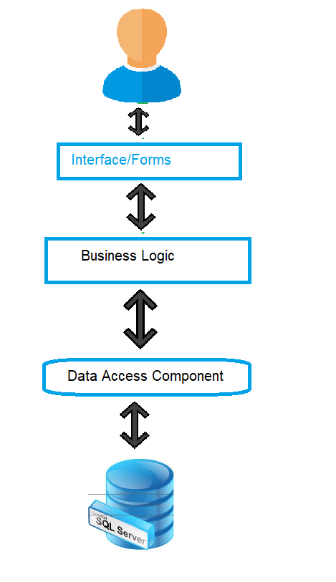Architecture Design Figure 3.0

1. Class Diagram

<Provide Class Diagram of the system>

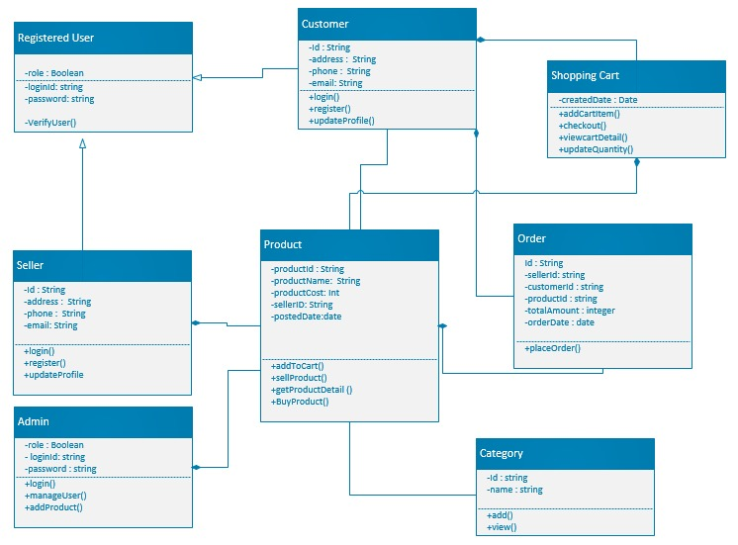

1. Database Design

<Provide Database Design Diagram of the system>

1. Interface Design

<Provide here the screenshots (GUI) of the system (Provide 3 or 4 main GUIs/interfaces, to show the most important features of the application as you are visualizing your application to be, in actual development phase. You can update these GUIs in Final Report and Final Presentation, in case they are changed after the actual development.>

1. Test Cases

<Provide test cases for each use case scenario>

**Test Case # 01**

Test Case Title : Testing the Admin : Login

|  |  |
| --- | --- |
| Preconditions | * Application must be running * Admin must be on Login interface |
| Actions | * Enter login Email & Password * Clicks on ‘Login’ button |
| Expected Results | Admin’s Main Interface Landed |
| Tested By | Bc170403299 |
| Result | Pass |
|  |  |

**Test Case # 02**

Test Case Title: Testing the Admin: Manage Profile

|  |  |
| --- | --- |
| Preconditions | * Admin must be logged in * Admin must be on main interface |
| Actions | * Click on View Profile Option from tool bar   Menu   * Enter new information if update profile   Information required   * Click on update button |
| Expected Results | Admin’s Main Interface Landed |
| Tested By | Bc170403299 |
| Result | Pass |
|  |  |

**Test Case # 03**

Test Case Title: Testing the Admin: Manage Profile

|  |  |
| --- | --- |
| Preconditions | * Admin must be logged in * Admin must be on main interface |
| Actions | * Click on View Profile Option from tool bar   Menu   * Enter new information if update profile   Information required   * Click on update button |
| Expected Results | Admin’s Main Interface Landed |
| Tested By | Bc170403299 |
| Result | Pass |
|  |  |